**ST.XAVIER,S COLLEGE**

**Maitighar, Kathmandu**



Digital Logic Lab Assignment #6

**Draw a circle using midpoint ellipse algorithm.**

Utsav Luitel

013BScCSIT046 (4th Semester)

**Submitted to**

|  |  |
| --- | --- |
| Er. Anil Sah  (Lecturer, St.Xavier’s College ) |  |

**Submitted date: August 21, 2015**

# ALGORITHM:

1. Input *rx*, *ry*, and ellipse center (*xc*, *yc*), and obtain the first point on an ellipse centered on the origin as

(*x*0, *y*0) = (0, *ry*)

1. Calculate the initial parameter in region 1 as



1. At each *xi* position, starting at *i* = 0, if *p*1*i* < 0, the next point along the ellipse centered on (0, 0) is (*xi* + 1, *yi*) and



otherwise, the next point is (*xi* + 1, *yi* – 1) and



and continue until

1. (*x*0, *y*0) is the last position calculated in region 1. Calculate the initial parameter in region 2 as



1. At each *yi* position, starting at *i* = 0, if *p*2*i* > 0, the next point along the ellipse centered on (0, 0) is (*xi*, *yi* – 1) and



otherwise, the next point is (*xi* + 1, *yi* – 1) and



Use the same incremental calculations as in region 1. Continue until *y* = 0.

1. For both regions determine symmetry points in the other three quadrants.
2. Move each calculated pixel position (x, y) onto the elliptical path centered on (*xc*, *yc*) and plot the coordinate values

***x* = *x* + *xc* , *y* = *y* + *yc***

**Source Code**

void drawpoints(int x,int y, int xc,int yc)

{

Form1->Image1->Canvas->Pixels[xc+x][yc+y]=RGB(255,0,0);

Form1->Image1->Canvas->Pixels[xc-x][yc+y]=RGB(0,255,0);

Form1->Image1->Canvas->Pixels[xc+x][yc-y]=RGB(0,0,255);

Form1->Image1->Canvas->Pixels[xc-x][yc-y]=RGB(255,255,0);

}

void drawellipse2(int xc,int yc,int a,int b,int x0, int y0);

void drawellipse1(int xc,int yc,int a,int b)

{

int p,x,y;

x=0;

y=b;

drawpoints(x,y,xc,yc);

p=(a*a)-(a*a*b)+((a*a)/4);

while((2*x*b*b)<(2*y*a*a))

{

if(p<0)

{

x=x+1;

p=p+((2*b*b*x)+(b*b));

}

else

{

x=x+1;

y=y-1;

p=p+2*((b*b*x)-(y*a*a))+1;

}

drawpoints(x,y,xc,yc);

}

drawellipse2(xc,yc,a,b,x,y);

}

void drawellipse2(int xc,int yc,int a,int b,int x0, int y0)

{

int p,x,y;

x=0;

y=b;

drawpoints(x,y,xc,yc);

p=b*b*(((float)x0+.5))* (((float)x0+.5)) + a*a*(y0-1)*(y0-1)-a*a*b*b;

while(y>=0)

{

if(p>0)

{

y=y-1;

p=p-((2*a*a*y)+(b*b));

}

else

{

y=y-1;

x=x+1;

p=p+((2*((b*b*x)-(y*a*a)))-(a*a));

}

drawpoints(x,y,xc,yc);

}

}

//---------------------------------------------------------------------------

void __fastcall TForm1::DRAWClick(TObject *Sender)

{

int xc,yc,a,b;

xc=StrToInt(Edit1->Text);

yc=StrToInt(Edit2->Text);

a=StrToInt(Edit3->Text);

b=StrToInt(Edit4->Text);

drawellipse1(xc,yc,a,b);

}

//---------------------------------------------------------------------------

# Output

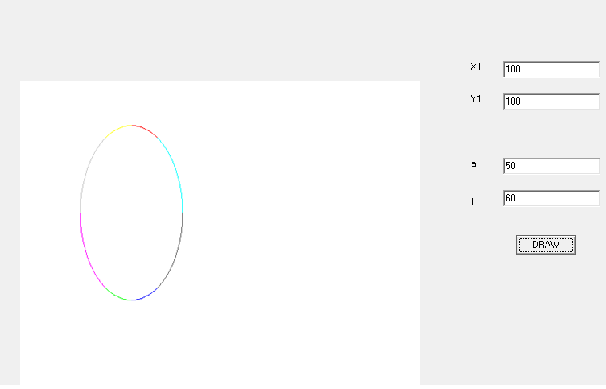

# Conclusion:

Hence, we constructed the ellipse using midpoint algorithm using C++ builder.

# Reference

[1] Er.Anil Sah,”CG Manual( 2015 ).pdf”